Coffeyville Area Community Foundation announces
Downtown Revitalization Grant Opportunity

Coffeyville Area Community Foundation is pleased to announce grant applications are open for Downtown Revitalization projects to improve and upgrade building and property exteriors in Downtown Coffeyville. The Downtown Revitalization grants are the current focus of the community foundation’s impact investing program.

Coffeyville Area Community Foundation recognizes improvements to the outside/exterior of buildings will enhance properties in Downtown Coffeyville making Coffeyville more attractive to citizens and visitors and improve the quality of life in our community.

The Community Foundation grant opportunity aligns with the City of Coffeyville’s Historic Downtown Façade Improvement Grant Program and Coffeyville Area Chamber of Commerce’s Storefront Improvement Program. CACF is pleased to offer an additional grant opportunity to improve downtown buildings and properties.

The CACF Downtown Revitalization grants to improve building exteriors are open to business and property owners in downtown Coffeyville. The grants are reimbursable matching grants for up to $5,000.

Downtown Coffeyville, for the purpose of this grant, is defined as 7th to 10th Streets and Elm Street to Patterson Blvd.

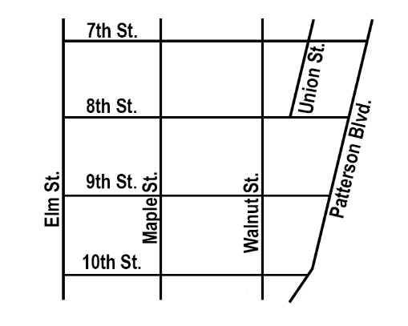

Eligibility requirements
- Downtown Coffeyville business owners and property owners are eligible.
- Projects improve the exterior of buildings/properties in Downtown Coffeyville
- Business owner and property owner approve of the exterior building improvements.
- Business owner or property owner secures building permit if required.
- Building improvements must begin after the grant is approved.
- Business or property owner is eligible for a reimbursable grant of up to $5,000 based on a dollar-for-dollar match if grant application is approved.

Please visit www.coffeyvillefoundation.org for additional information or call Coffeyville Area Community Foundation, 620-251-4769.

